Exercise 4: Geo-Referencing, On-Screen Digitizing, & GPS

Jatin Chowdhary

Lab Section #03

Wednesday, November 15th, 2017

Michele Tsang

* 1. With respect to raster datasets, pyramids are a down-sampled version of the original raster
* dataset and can contain many down-sampled layers. Each successive layer of the pyramid is
* down-sampled at a scale of 2:1. Pyramids are used to improve performance.

Pyramids are useful because they can speed up the display of raster data by retrieving only the data at a specified resolution that is required for the display. With pyramids, a lower-resolution copy of the data displays quickly when drawing the entire dataset.

2. Updating produces a “world file”. It does not create a new raster dataset – avoiding redundancy.

Rectifying produces a new raster dataset that is georeferenced using map coordinates and a spatial reference.

3. For the control points, I used distinct features such as edges/vertices of buildings, end of roads, and unique features such as landscapes. This is because they are distinguishable and unique, enabling an accurate georeferenced image.

4. After selecting the first point, the image drastically changed position and aligned itself to the first control point, however, the image was still tilted.

5. With each successive control point, the image and the shape-file(s) aligned up to the point that the features on the shape-files were accurately lined up with the features on the image. [i.e. BSB on CampBuildings.shp over-laid on campus.jpg]

6. RMS error is an acronym for root mean square error. It measures deviance between actual and estimated locations of ground control points. It is calculated by squaring the differences between known and unknown points, adding them together, dividing them by the number of points, and then taking the square root.

7. The smaller the RSM error value, the better, because it indicates that predicated and observed values are fairly close. A small RSM error value would be ideal because it shows that the layers are accurately lined up, and in the real world, very close to each other. For this assignment, an acceptable level of RMS error should be less than 3. This is because it indicates a small deviance (3 meters) between actual and estimated location.

8.

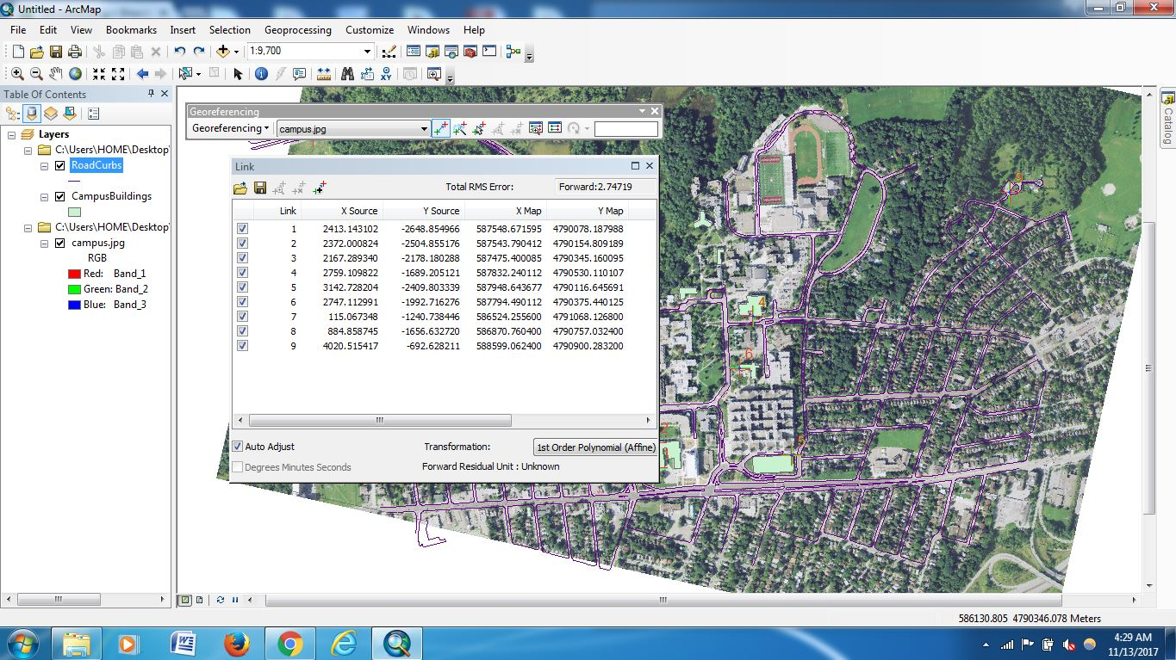

9. The spatial reference of the image is: NAD_1983_UTM_Zone_17N

The linear unit of the image is: (Meter) 1.000000

10. 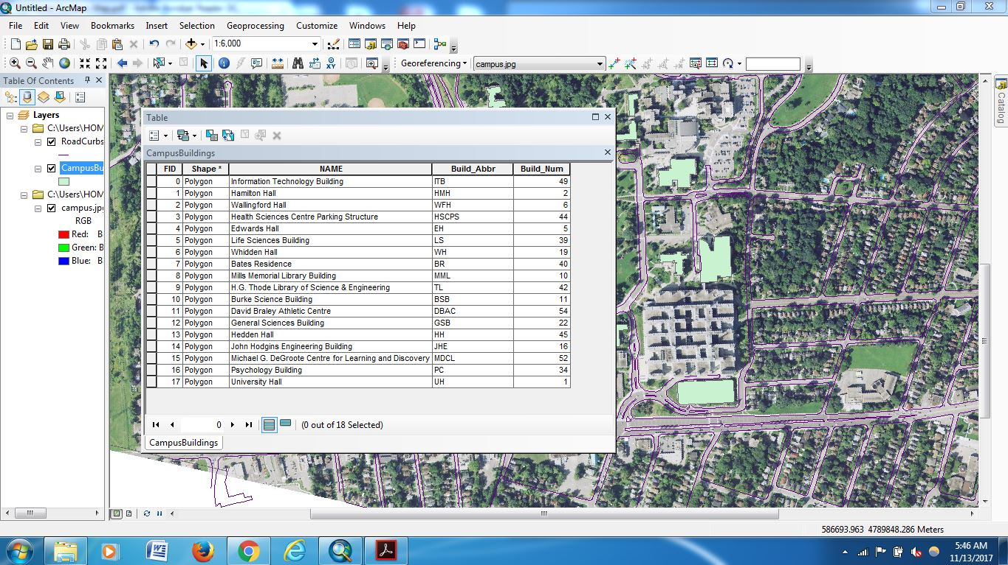

11. 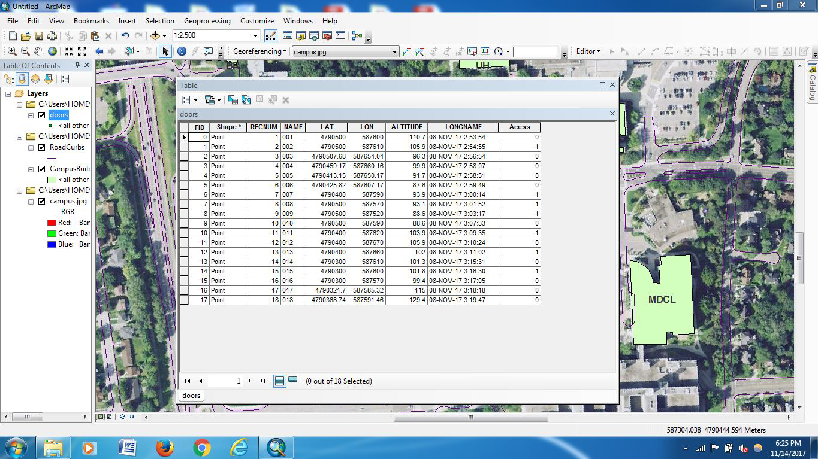

12.

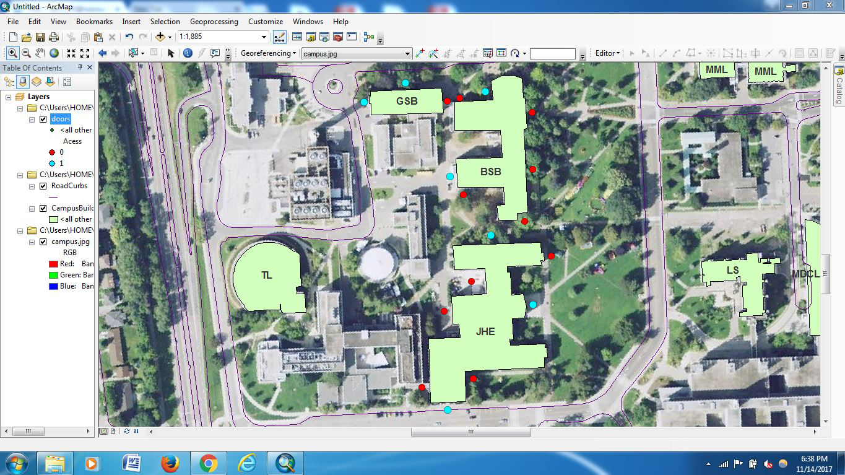

And, In Case You Wanted The Full Extents…:

